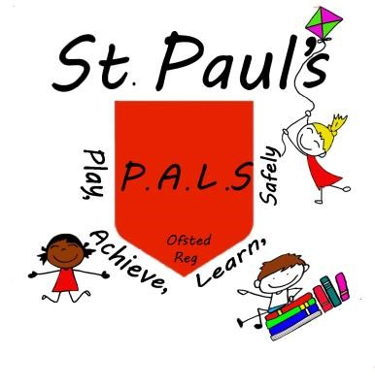
St. Paul’s PALS Childcare

Play, Achieve, Learn Safely
St. Paul’s PALS is an Ofsted registered childcare provision which provides wrap around care at St. Paul’s Primary School. Priority is given to St. Paul’s pupils although school aged children may attend from other settings. All children must be registered with PALS to attend and it is advisable to book in advance to secure a place. Sibling discounts available. Holiday care and extra hours are also available by arrangement. Please contact Mo Tierney for details, either in school or on 07745385470.

Mornings (Breakfast provided until 8.25am)

7.30am–8.45am (Earlier starts by arrangement only)
Pre-Booked Sessions First Child £5.50 per session
Extra Siblings £5.25 each per session
Occasional Care £6.50 per session per child
8.15am-8.45am £3.50 per child per session

Afternoons (Meal provided at 4.00pm)
3.15pm-3.45pm £3.50 per child per session

3.15pm-4.30pm (Including meal)
Pre-Booked Sessions First Child £6.00 per session
Extra Siblings £5.75 each per session
Occasional Care £7.00 per session per child

3.15pm-5.30pm (Including meal) (Later finishes by arrangement only)
Pre-Booked sessions First Child £8.50 per session
Extra Siblings £8.25 each per session
Occasional Care £9.50 per session per child
PLEASE NOTE THAT WE CLOSE AT 4.30pm ON FRIDAYS.

